Computer simulations in power and process engineering
2018/2019
doc. dr. Matjaž Ramšak (Google: Matjaz Ramsak, first hit)
mail: matjaz.ramsak@um.si
version 4.10.2018

Contents
1 Motivation 2
2 Obligations (Seminar) 3
2.1 Simscale tutorial 3
2.2 Paraview tutorial (for results post processing) 3
2.3 Validation case (Long Report as in Validation case.) 3
2.4 Turbulent backward facing step flow (Long Report as in Validation case.) 3
2.5 Your case (Long Report as in Validation case.) 3
3 Time schedule 3
4 Problem Based Learning (PBL) 3
5 Literature and help 3
5.1 Computational Fluid Dynamics 3
5.2 CFD Online 4
5.3 CFD Best Practice 4
6 CFD software 6
7 SimScale 6
8 SimScale Tutorial 6
9 ParaView Tutorial 10
10 Validation case 12
11 Your case 13
12 Turbulent flow: backward facing step flow 13
13 Exam 16

Motivation

To learn open source Computational Fluid Dynamics (CFD) web based program SimSCALE in order to solve basic problems in power and process engineering.

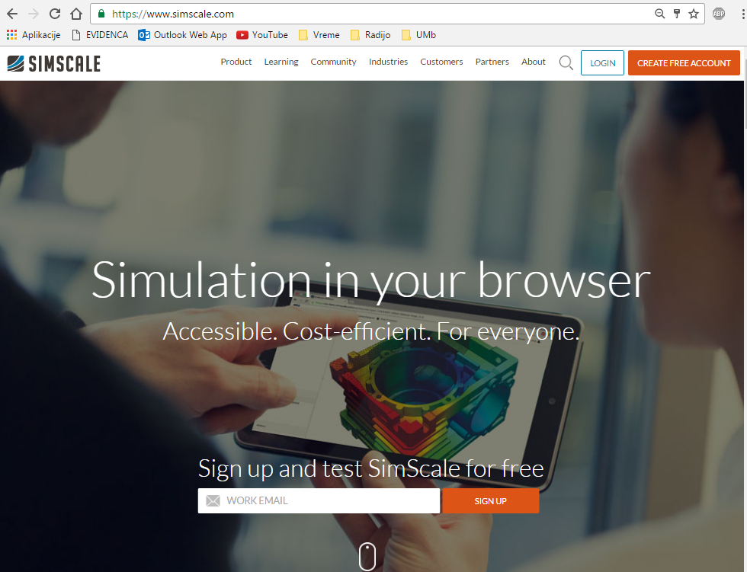

Obligations (Seminar)

Simscale tutorial

Paraview tutorial (for results post processing)

Validation case (Long Report as in Validation case.)

Turbulent backward facing step flow (Long Report as in Validation case.)

Your case (Long Report as in Validation case.)
The exam includes the presentation of all activities.

Time schedule
Load presentation on Moodle and present it in the class dated:
date | what to do
11.10.
23.10. | Tutorial
16.11. | Validation case
4.12. | Turbulent flow: backward facing step flow
19.12. | Your case
20.12. | Exam

All presentations must have a positive mark to pass final exam.
There is no second chance afterward.

Problem Based Learning (PBL)
reference: https://en.wikipedia.org/wiki/Problem-based_learning
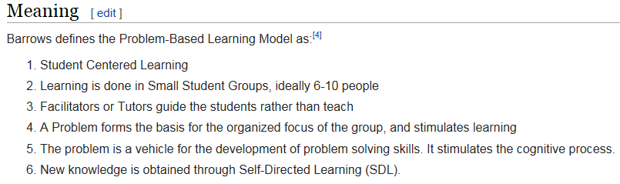

Literature and help

Computational Fluid Dynamics
reference: https://en.wikipedia.org/wiki/Computational_fluid_dynamics

CFD Online
http://www.cfd-online.com/Wiki/Main_Page

CFD Best Practice
http://www.cfd-online.com/Wiki/Best_practice_guidelines
https://www.nas.nasa.gov/assets/pdf/Kiris_AresV_CFD_BestPractices.pdf
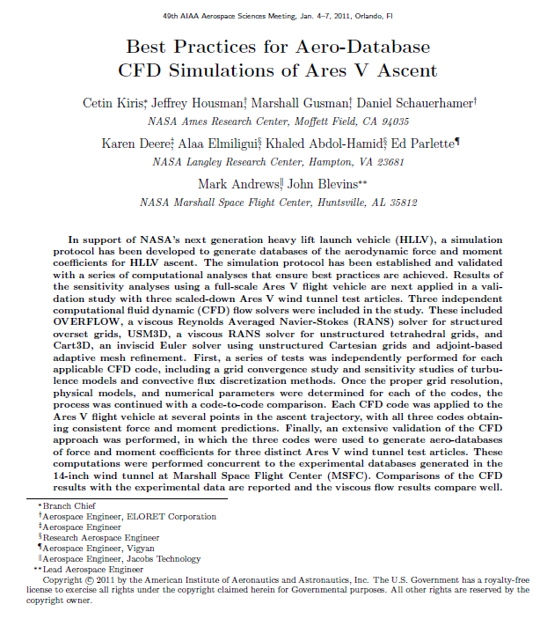
http://www.ercoftac.org/publications/ercoftac_best_practice_guidelines/

CFD software
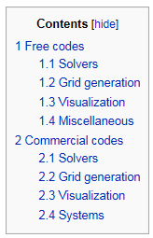
- ANSYS (CFX, Fluent)
- AVL (Fire)
- StarCD
- …

SimScale
https://simscale.com/_en/
The best StartUp project 2015 in Germany.
- Basic idea
- OpenFoam
http://www.openfoam.com/
  - not simple to use it
- Postprocesing: Paraview
http://www.paraview.org/

SimScale Tutorial
The default tutorial to do is:
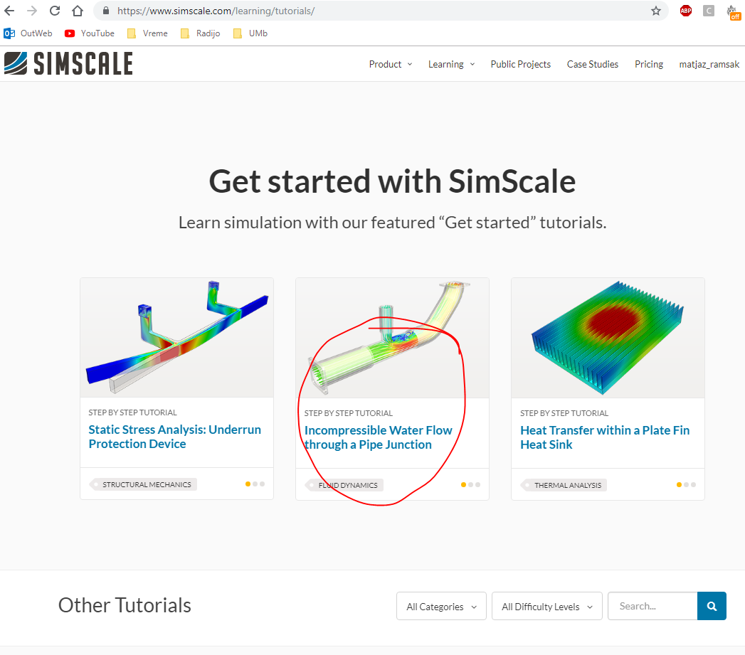
You can do also another tutorial from this page or whatevewer you find.
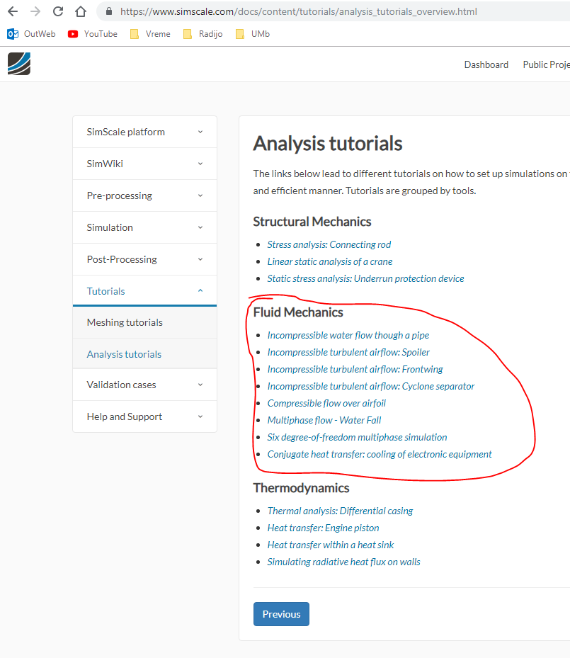

During the tutorial you have to do report including Print Screens with individual background visible as shown below in order to prove your work.
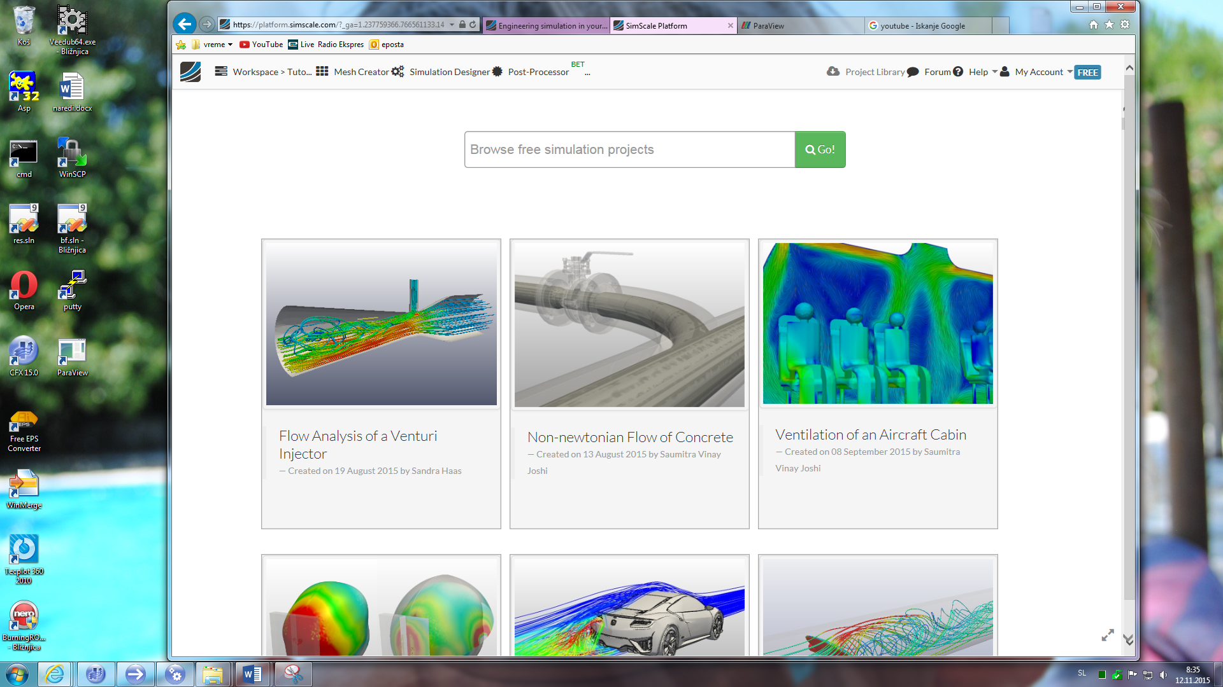
Of course, you should add the text in order to make your reports reasonable.
The main motivation for this is to do reports for your using later and to show somebody else.

ParaView Tutorial
Tutorial is located here: http://www.paraview.org/Wiki/The_ParaView_Tutorial
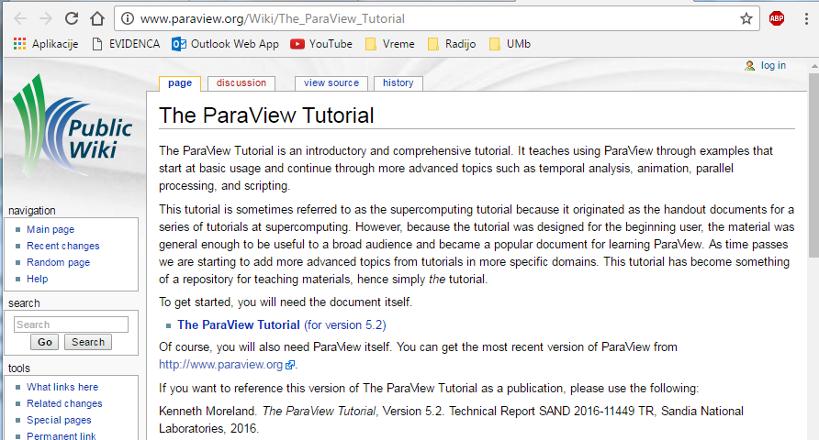
Make complete Basic usage section. Make a report as in Simscale tutorial.
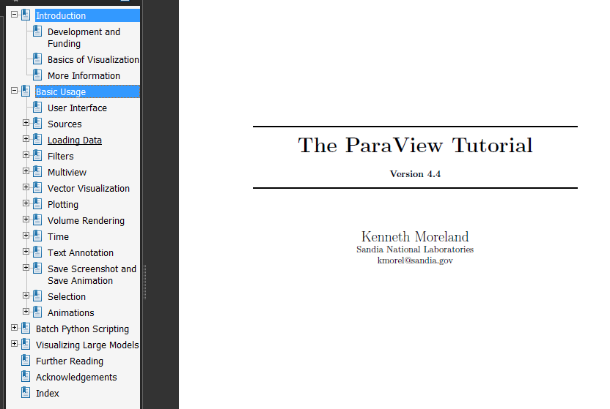

Validation case
You choose your validation case using
https://www.simscale.com/docs/content/validation.html
sections: Fluid Dynamics or Thermal simulation.
Or find yourself another validation case with known solution, which could be analytic, numeric from other authors or experimental. For example:
- driven cavity flow,
- natural convection in cavity,
- heat transfer
First, you have to repeat it obtaining the same solution(s) as reference.
Second, change something (mesh, temperature, material properties...), recompute the case and make engineering conclusions including numbers (Sensitivity analysis). For example: if the power of heater is increased from 100W to 200W (by 100\%) the temperature difference is increased from 40.3°C to 65.1°C (only 62%, due to the increased heat loses).
Make complete report structured as follows.
- Title page (One page)
  - Your personal data
  - Title
  - Abstract (max. 8 sentences). Answer to:
    - What have we done (including Sensitivity analysis)
    - How
    - Why
    - What have we learned
  - Nice figure (or two)
- Introduction
  - Problem definition
  - Theoretical grounds
  - Sensitivity analysis 1 (mesh)
  - Sensitivity analysis 2
  - ...
- Geometry
- Computational mesh/es
- Boundary conditions
- Results convergence
- Results
  - Figures and tables
  - Comparison with other solutions (if exist)
  - Sensitivity analysis results
  - ...
- Conclusions. Answer the abstract question “What have we done” in few paragraphs.
- The final results should be like this:
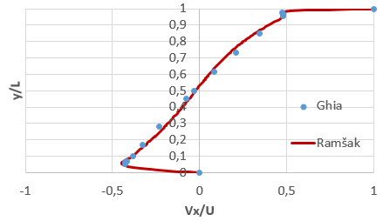
or/and in Table like this
 | Reference | My soulution
 |  | Variation 1 | Variation 2
∆p (Pa) | 2.0 | 2.1 | 2.001
Heat Flux (W) | 10.0 | 11.1 | 10.1
STEP flow: x/H_{reattach} | 6.26 +- 0.10 | 5.80 | 6.10

Your case
Compute your case of interest. You may use Simscale public projects.
Make similar report as described in Validation case section.

Turbulent flow: backward facing step flow
The main aim of this Homework is to compute turbulent flow and make comparison with measurement shown in reference:
https://turbmodels.larc.nasa.gov/backstep_val.html
The problem definition is clearly stated in reference. The results has to be compared in nondimensional graphs using x/H and y/H coordinates where H is step height. Each student has its own value for H defined in next Table.
Student | step height H[cm]
Clément Turbin (FRA) clement.turbin@gmail.com 24.9.2018 - 22.2.2019 | 1.5
Joao Pedro Pestana (PRT) pedropestana@ua.pt 24.9.2018 - 12.7.2019 | 2.5
José Pedro Moura Costa Pinto (PRT) JOSEMCP@UA.PT 24.9.2018 - 12.7.2019 | 3.5
Marek Kopèak (SVK) MAREKKOPCAK@GMAIL.COM 24.9.2018 - 22.2.2019 | 4.5
Adrian Kollar (SVK) ADR.KOLLAR@GMAIL.COM 24.9.2018 - 22.2.2019 | 5.5
Andrej Hovanec (SVK) ANDREJHVC@GMAIL.COM 24.9.2018 - 22.2.2019 | 6.5
Kristián Csótó (SVK) KRISZTI.CSOTO@GMAIL.COM 24.9.2018 - 22.2.2019 | 7.5
carlos ayuso (ESP) CAYUSO96@GMAIL.COM 24.9.2018 - 12.7.2019 | 8.5

The report of this work has to be the same structure as stated in section Validation case. The Mesh sensitivity analysis has to be performed. In addition, another parameter analysis of your choice has to be done.
Compare Recirculation (reattachment) length.
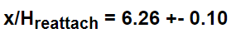
Additionally compare your results with this plots.
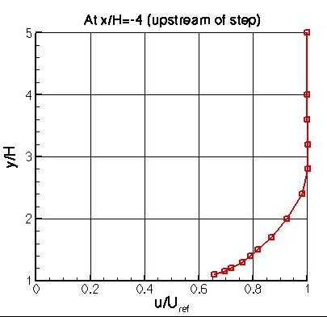
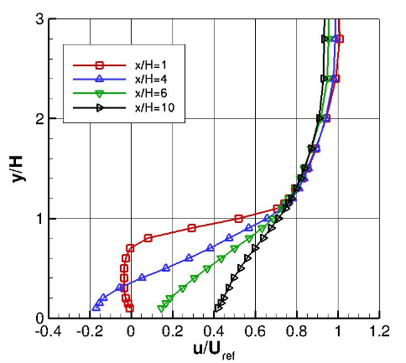
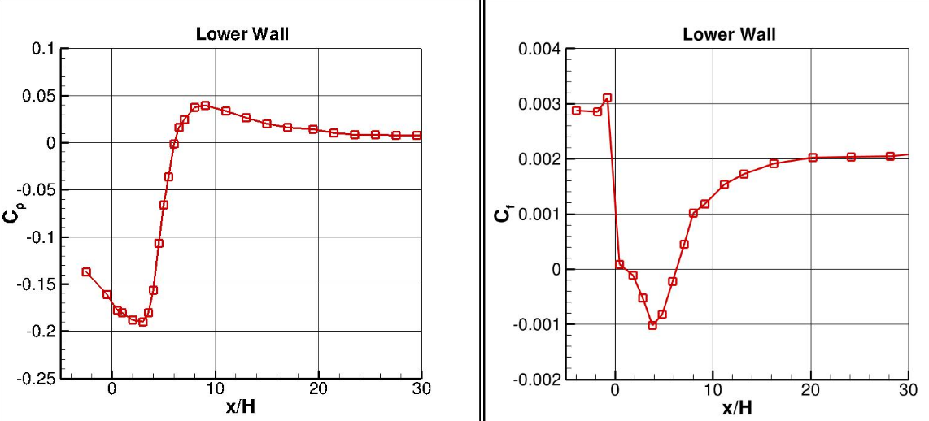

Exam
For exam, all reports are evaluated using marks.
You have to do 10 min presentation for validation case, Backward facing step flow and another 10 min presentation on Your Case at dates stated before.
The final mark includes:
- difficulty of your cases
- activity during lectures
- the report quality
- presentation

